The purpose of this document is to provide procedural steps to archive/backup Microsoft Outlook. Office 365 doesn’t offer backup of e-mail contents, hence it is necessary for e-mail users to ensure they can back up the contents of their mail box.
The procedure is very simple, one just need to check there is enough storage space to store the file that will contain the outlook data, this could be saved locally in the computer, a network shared location, or other external storage media. To check the size of the Outlook datafile do the following:
While Outlook is open, click the menu File/Account Settings/Account Settings …
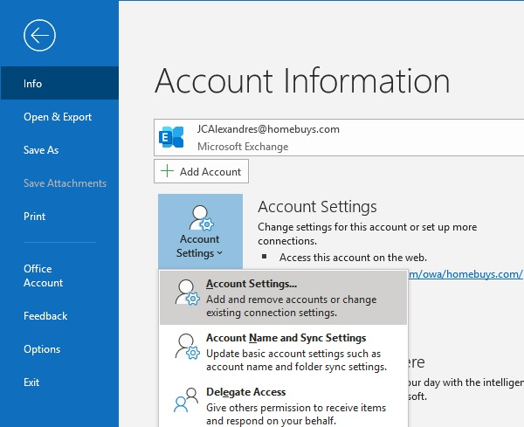
… in the box that opens navigate to the tab Data Files, select the file that resembles your e-mail address, then click Open File Location …
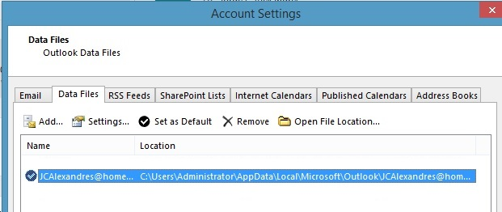

… look for the OST file with the same name as your e-mail address make note of the size.
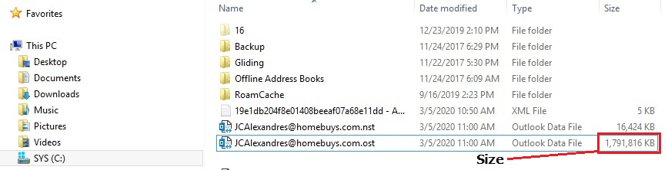
It is very likely your computer has enough space to store the file, to find out how much space is available in your computer, open File Manager, in the left side select This PC, and look on the right side pane the information of the C: drive, despite the computer or mapped network drive will have enough space, still is important to know the size., as some of you may have an external hard drive enclosure to back up your files, pictures, etc., or even a USB thumb drive. Once you have decided where to store the file, while in Outlook do the following:
- Customize the Quick Access Toolbar: Click the drop-down list of options, click More Commands, in the Choose commands from drop-down list box, select All Commands …
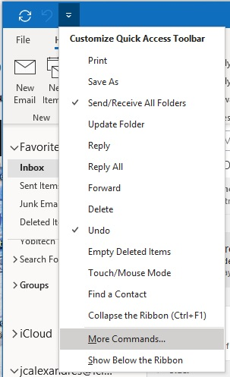

… select one of the first entries in the list, then enter imp in the keyboard, the election will move down the list to select Import & Export, click the button Add, then OK …
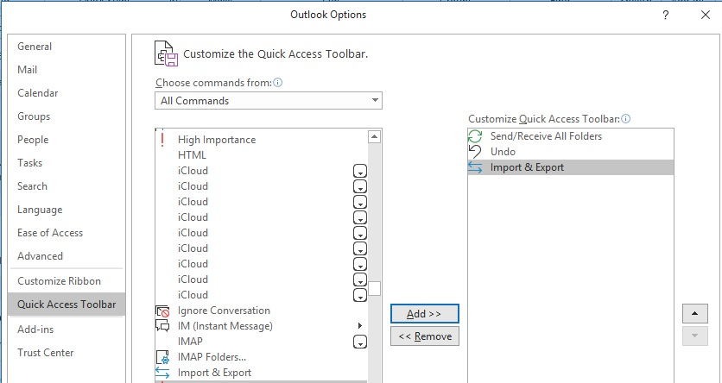
the Import & Export icon shows now in the Quick Access Toolbar.
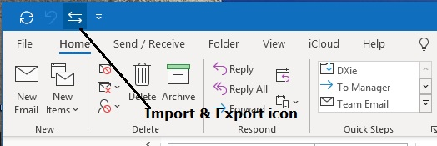

- Create a backup of the contents in Outlook via exporting to an Outlook file or CSV type, depending what you are backing up, e-mail contents to a PST type, Contacts to CSV type …
To start, click the Import & Export icon, select Export to a file in the Import and Export Wizard screen, then click Next …
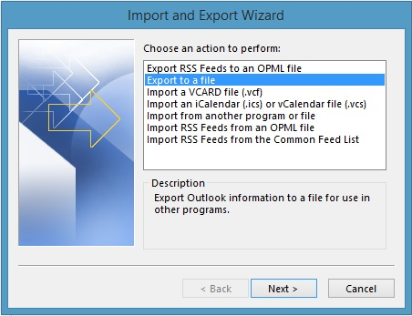
We’ll backup/archive the e-mail contents first, so at The Export to a file options dialog box, select Outlook Data File, then click Next …
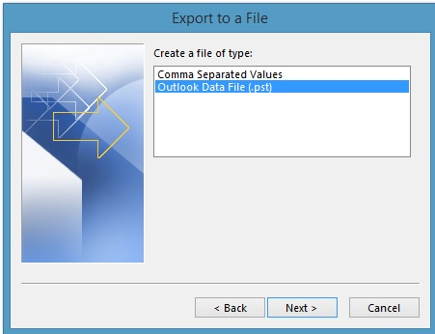

At the Export Outlook Data File dialog box, select the top entry, which should be your e-mail box name, typically your e-mail address, and click the box Include subfolders, click Next …
(This selection will back up the current state of all the contents of the e-mail box)
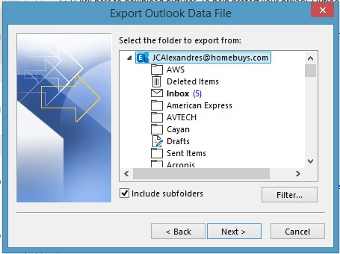

Select where to save the file using the Browse button, else it will be stored in the same location of the Outlook data file reviewed in the Accounts Settings step, this is not recommended as if the user’s profile goes corrupt or have hard drive issues, very likely the file will be lost, save the file to a folder locally or network attached drive, if locally, do an extra step to eventually copy the file to a USB thumb drive or SD card. For this example, a directory Backup created in the C: drive will be used, so the entry in the Save exported file as is C:\Backup\JCAlexandres – 030520 – Archinve.pst, this reflects the location as C:\Backup\ and the name of the file with the .pst extension …
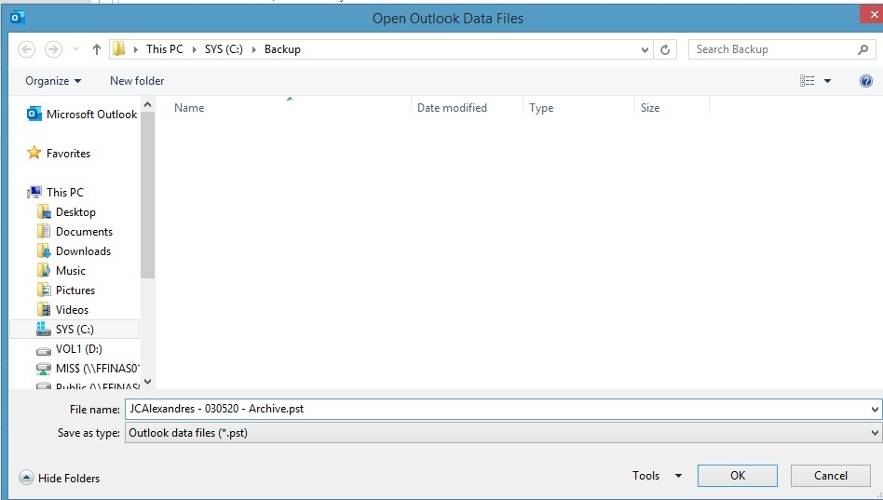
… In this example it was selected Do not import duplicate item, click Finish, password is optional, click OK to start …
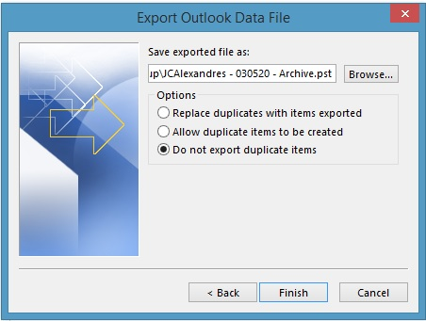
The status box in the picture below will remain until Outlook finishes exporting the selection …
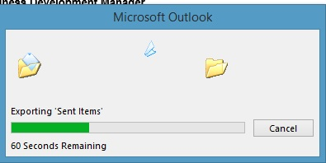
When done, the data file can be attached to Outlook for recovery purposes, or simply to browse archived data. Any contents deleted while the data file is attached will be hold on it’s own Recycling bin, and not recoverable if removed from there. To do so, use the File/Account Settings/Accounts Settings/Data Files, click Add, select Outlook data file (.pst), click OK and browse the location where the export was saved, once attached, it will show in the Outlook interface as another mail box. Eventually the file can be detached from Outlook and the data files area, this will not erase the file in the computer, just remove from Outlook.

Exporting contacts is similar the above procedure, provided the Quick Access bar has been modified to include the Import & Export applet, to export and create an archive/backup, do the following:
- Click the Import & Export icon, select Export to a file in the Import and Export Wizard screen, then click Next …
At the Export to a File screen select Comma Separated Values, click Next …
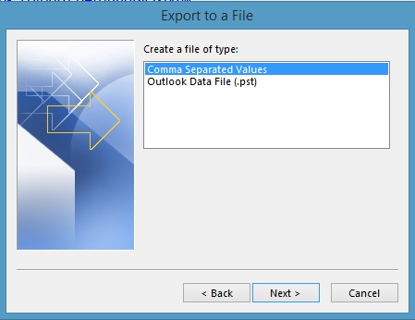

Scroll down and select Contacts, be sure to be at the proper mail-box if you use more than one e-mail address in Outlook, click Next
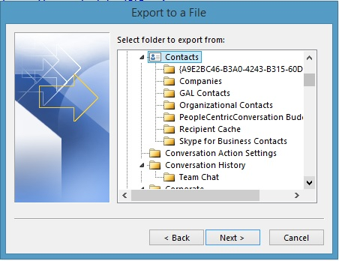
Select the name of the file and location to save … Follow the examples of exporting the mail box …
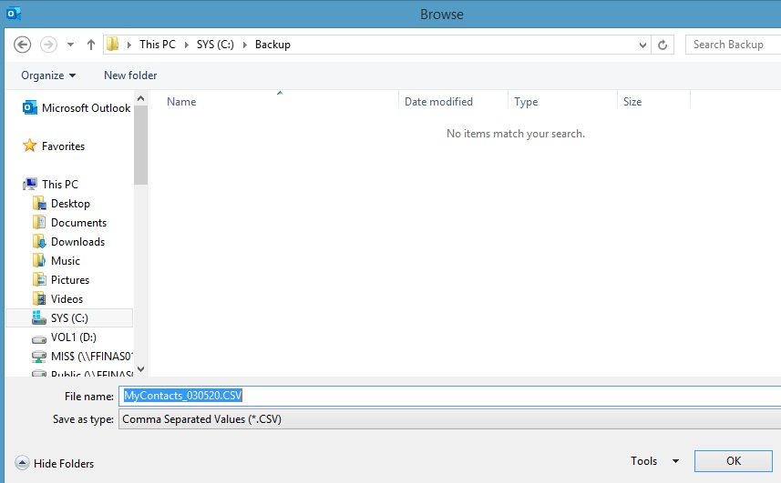
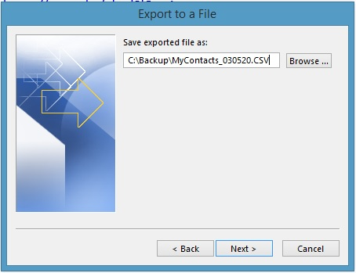
The exported data could be imported into other contact management applications, where the functionality of the Map Custom Fields become handy. Click Finish to execute …
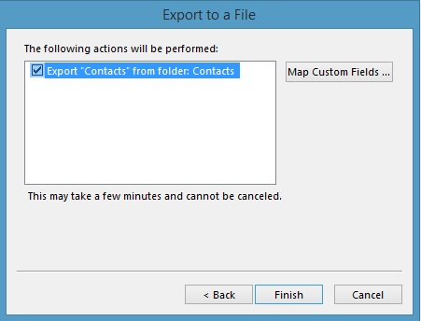
If Microsoft Excel is installed in the computer, the created file can be opened with Excel, or any CSV capable application.

If you need help with any of these steps, please do not hesitate to open a help desk ticket at http://helpdesk.homebuyscorp.com/ while connected at any of the Home Buys networks.

Jorge C. Alexandres
Network Administrator
Home Buys, Inc.
www.homebuys.com
234-209-9840 x 244
330-774-6954 cell

